IceSmack

*Admin Guide*

|  |  |  |  |
| --- | --- | --- | --- |
| **Supervisor.** | Sir.Zaman | |  |
| **Batch.** | 2103F | |  |
| **Group.** | 1 | |  |
| **Serial No.** | **Enrollment Number** |  | **Student Name** |
| 1. | Student1307408 |  | Muhammad Fawad |
| 2. | Student1308866 |  | Raheem Ramzan |
| 3. | Student1298516 |  | Harish Kumar |
| 4. | Student1299967 |  | Umair Ali Bhutto |

Home Page

When Site is opened Admin will be greeted with the home page.



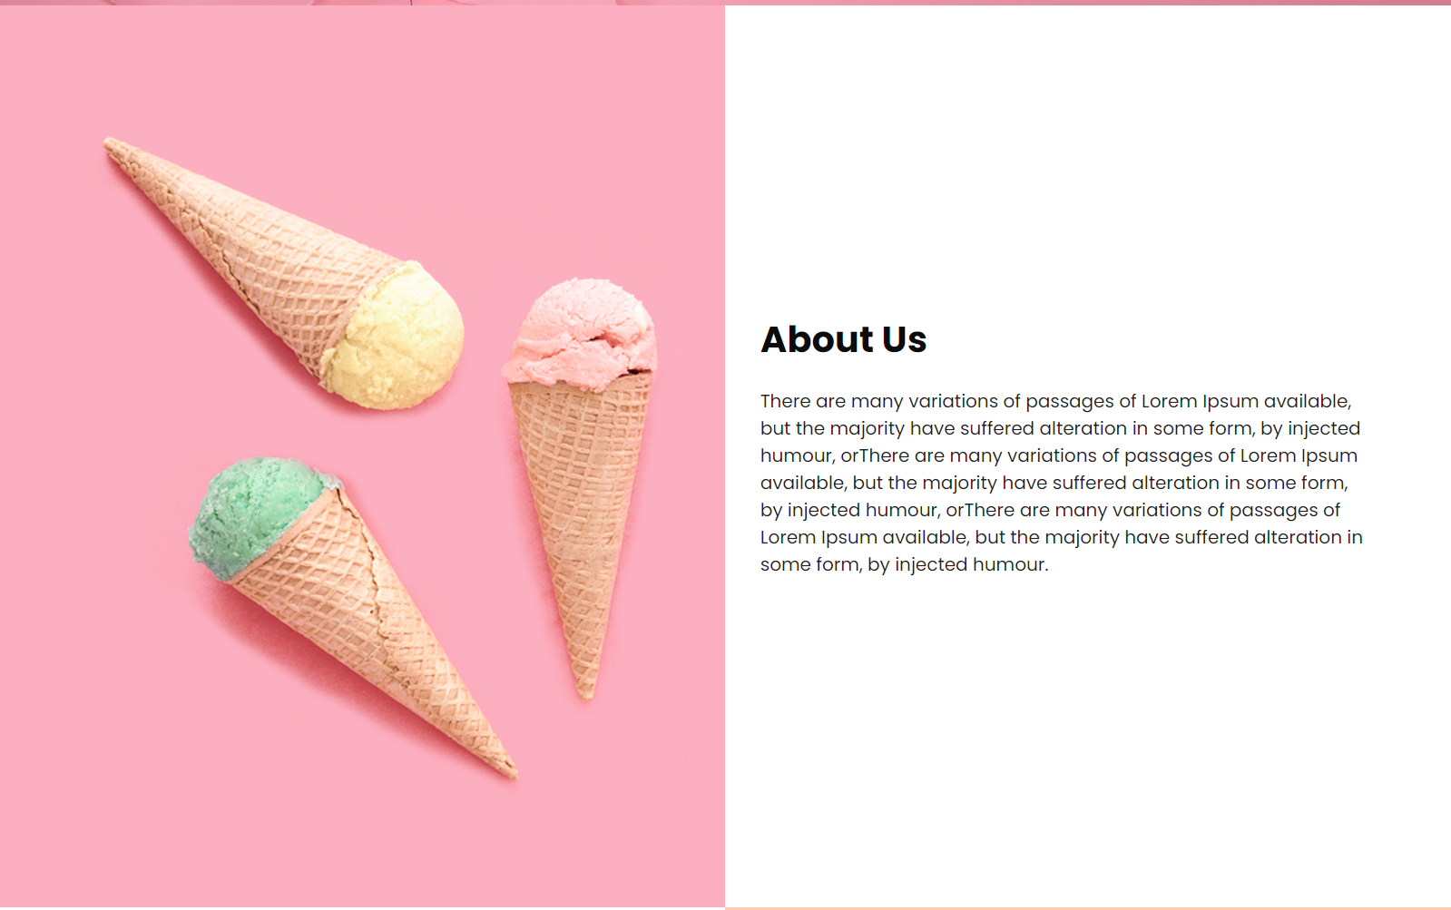





For the access of Admins in this project admin will go towards the address bar and will type /admin.





It will take you towards your admin login.

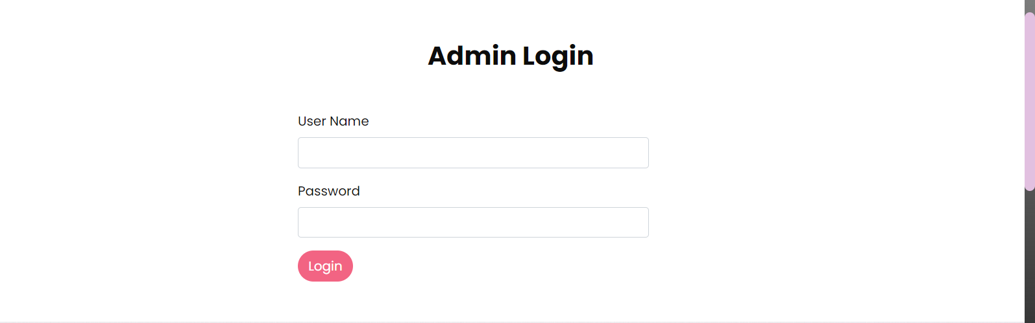

After filling your username and password provided by your provider op

You will be diverted towards the recipes page with full admin access.

On the recipes page admin will be able to create new recipes, update the previous ones, delete any recipes, and can view all details of the recipes.

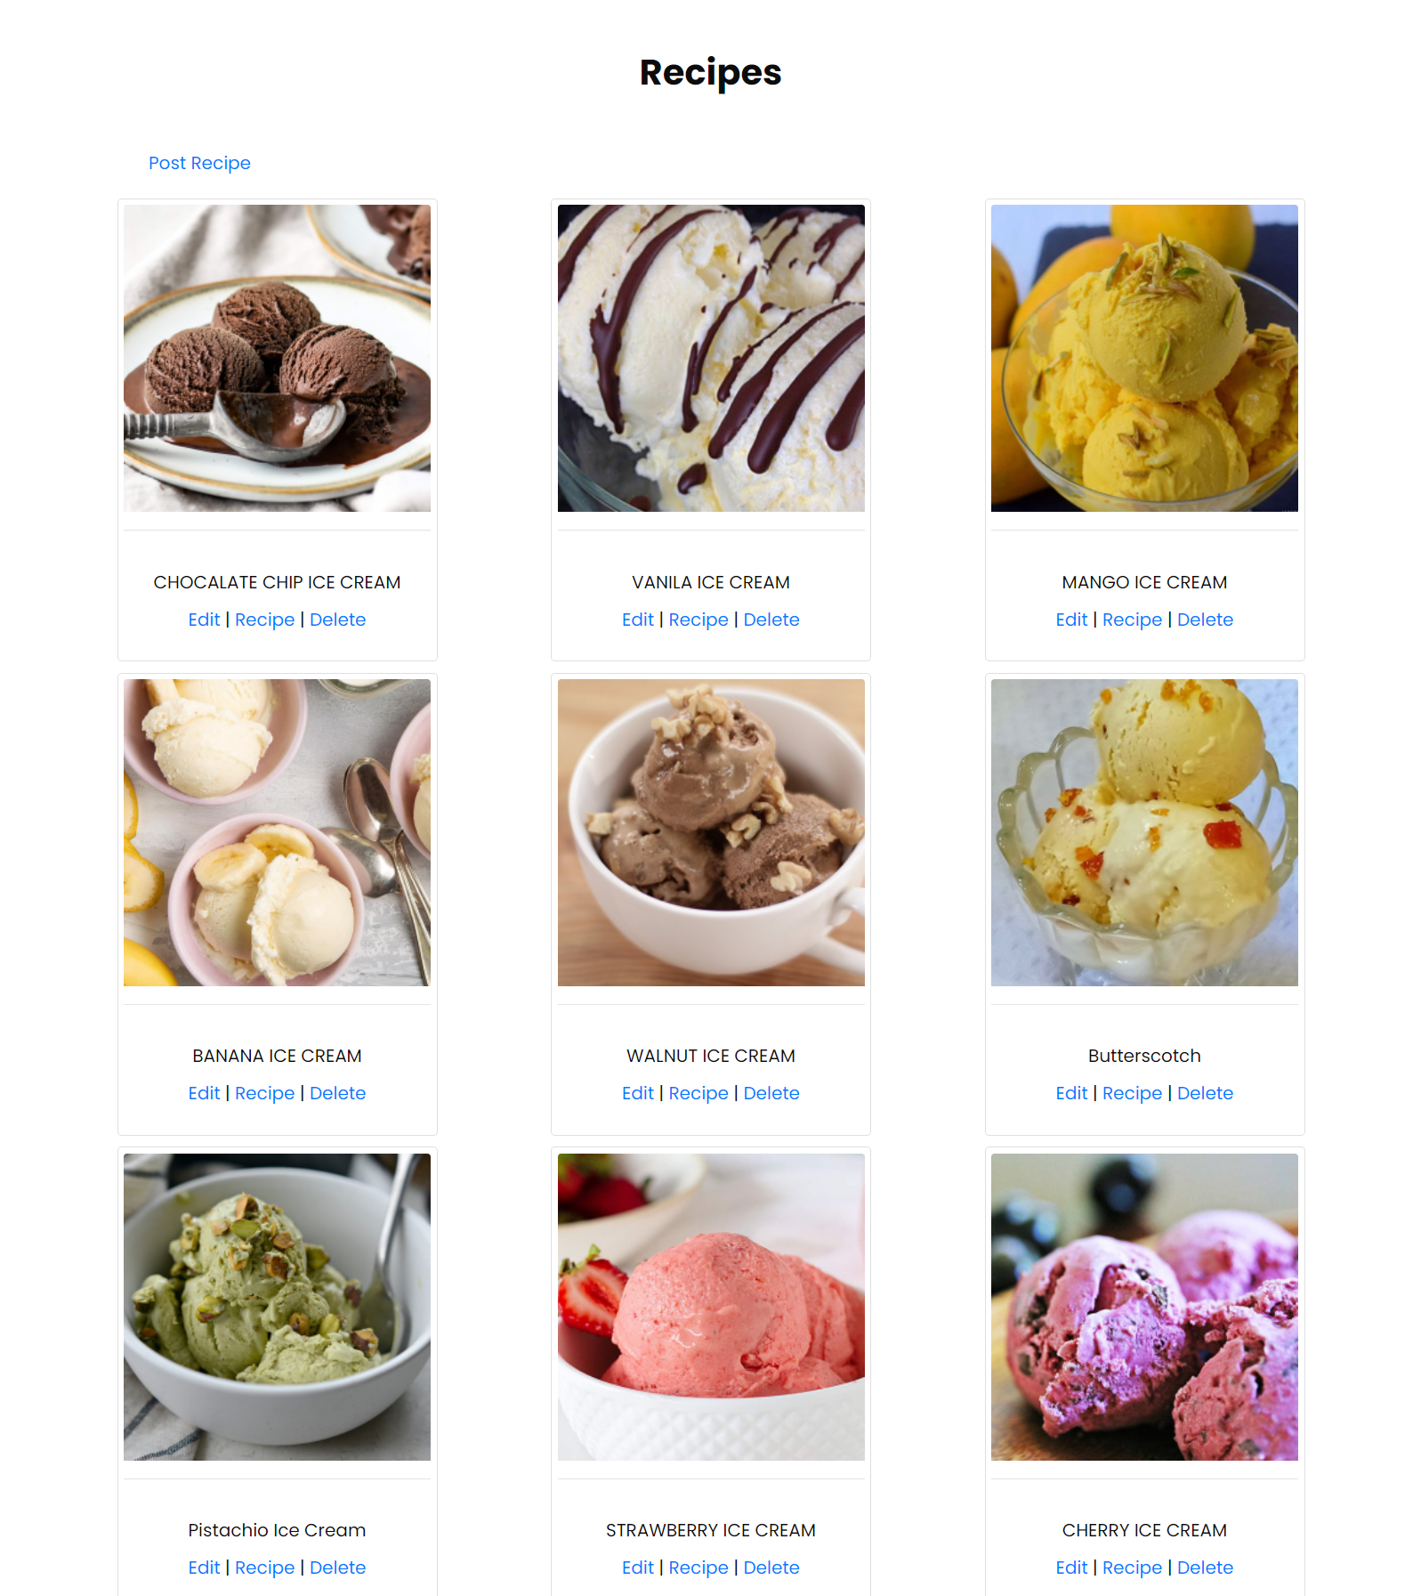

After clicking Edit. Admin can edit details.

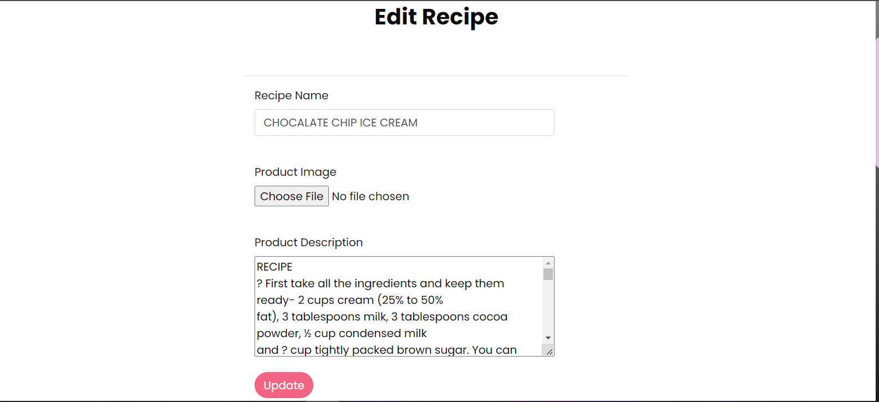

Admin can create recipes

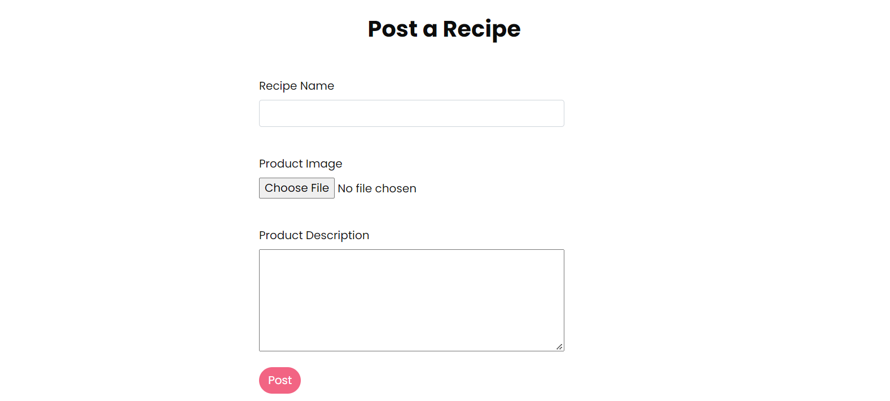

Admin can see all recipes details.

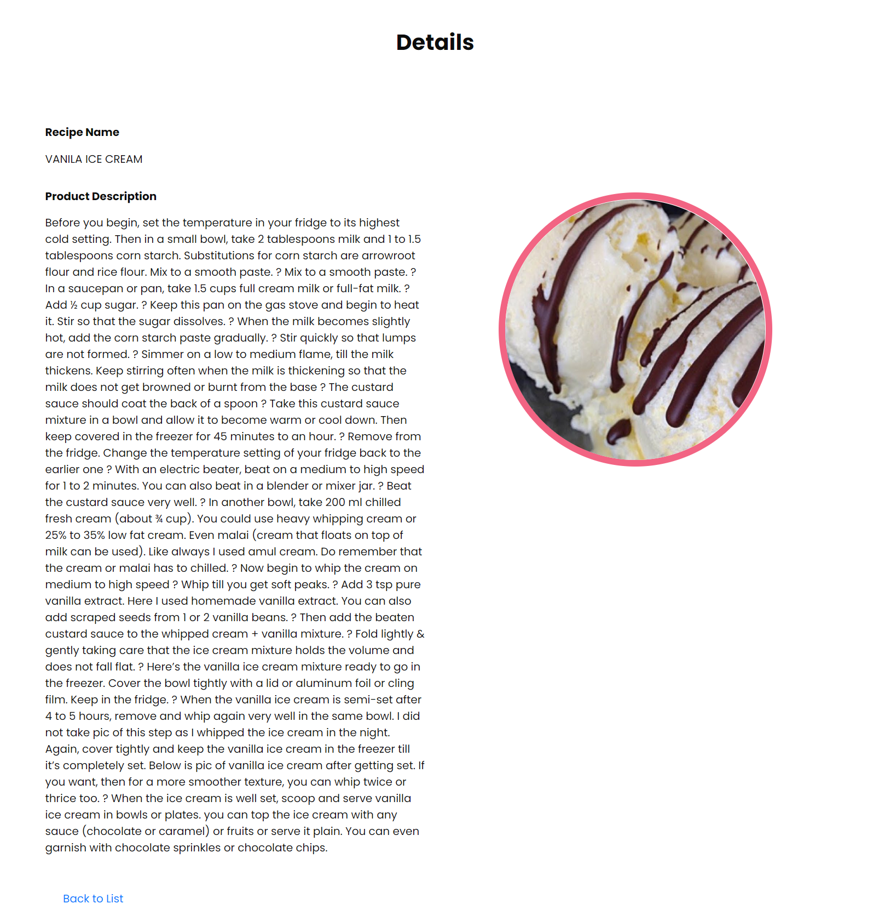

Admin can delete recipes as well

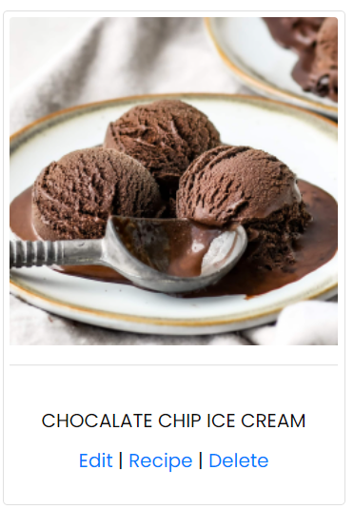

Admin can see feedbacks of customers.

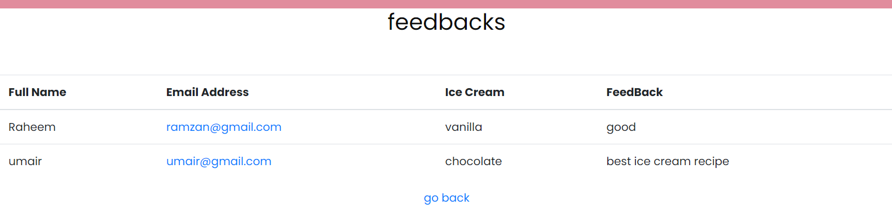

Admin can see registered users.

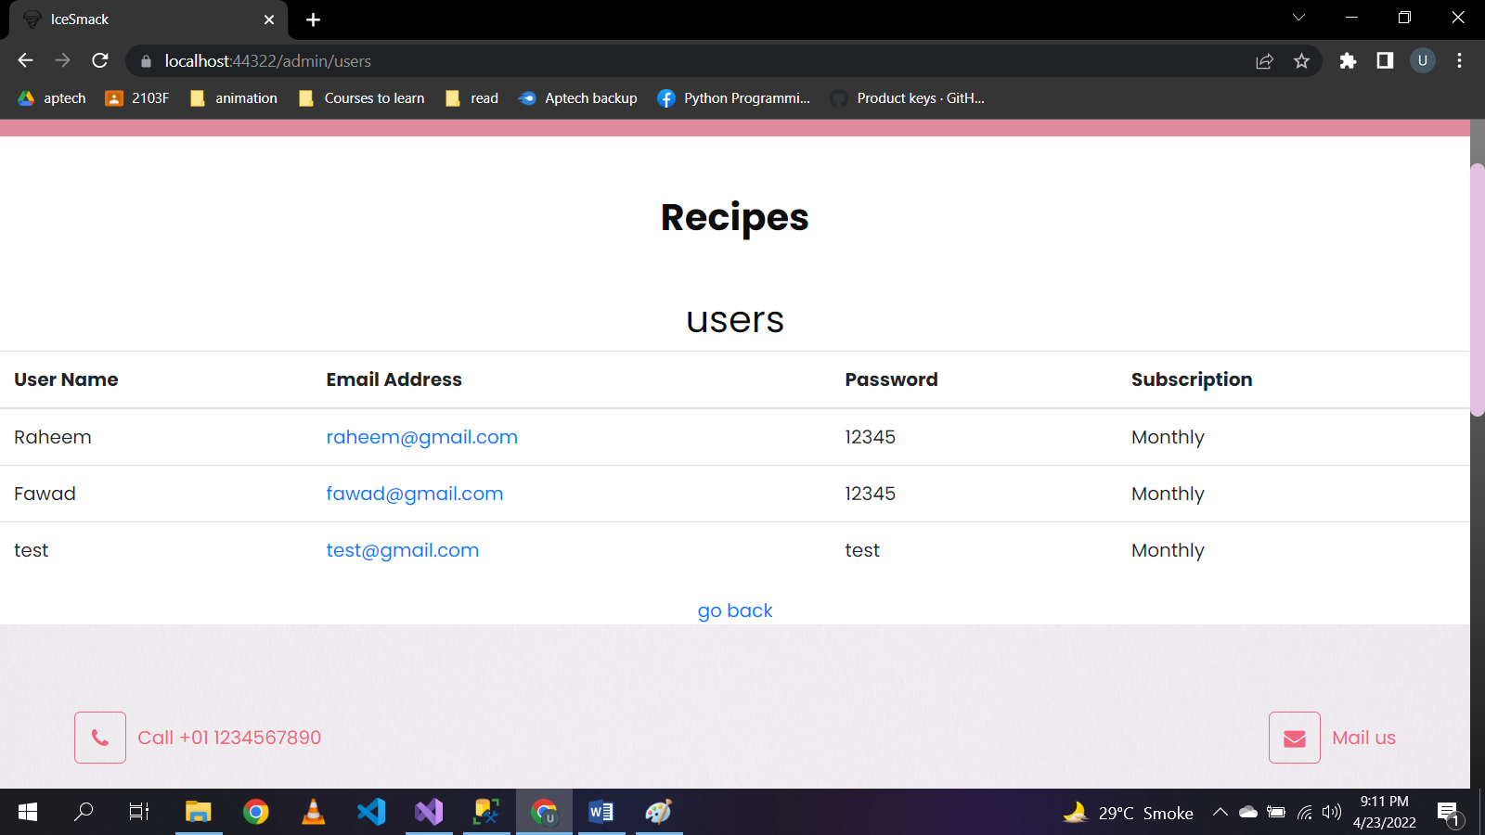

Admins can see bought books details.

